Test Case: tc002_SPX_Dev5_Crear_Requisicion_Spot_Tipo_Cobro_Project
Step 1 - Enter username and password and click to button Enter: Credentials Entered
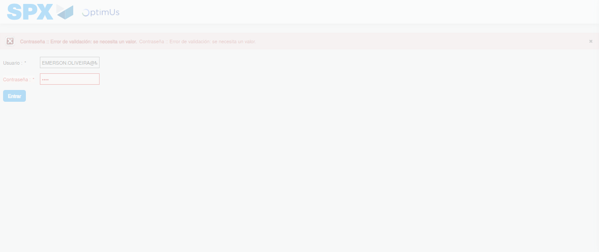Image file-name: QC_Testing-tc002_SPX_Dev5_Crear_Requisicion_Spot_Tipo_Cobro_Project-1784226402570

Step 2 - Select to UEN and Access to Spot Buy Requisitions : UEN Correctly selected and Correct access
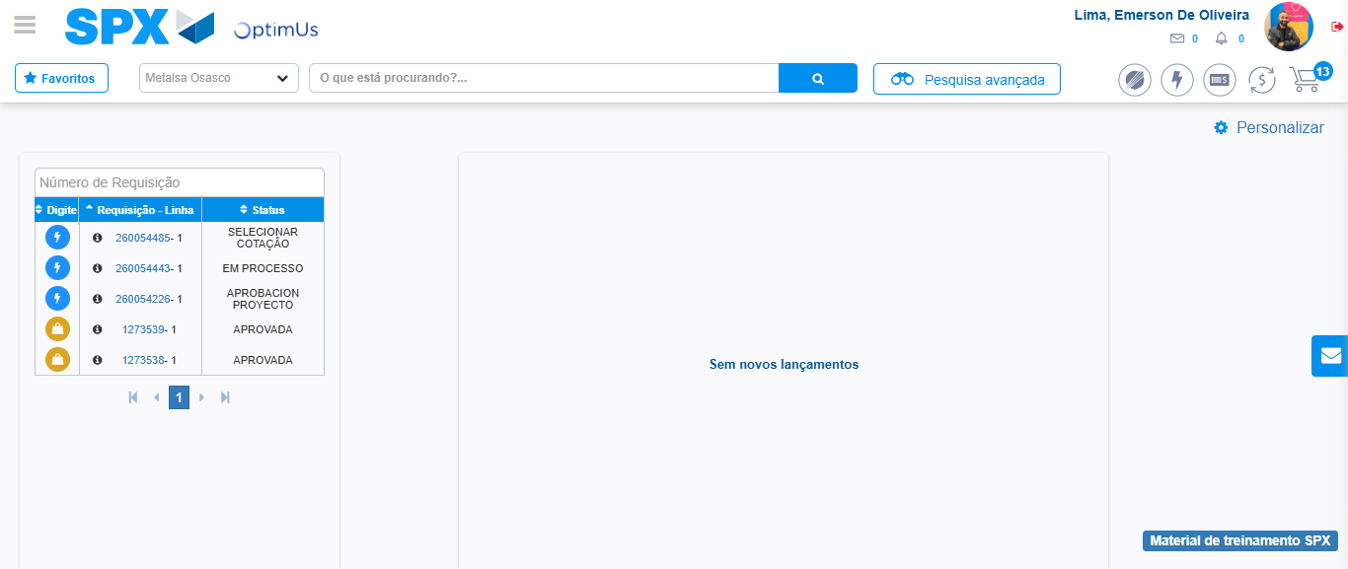Image file-name: QC_Testing-tc002_SPX_Dev5_Crear_Requisicion_Spot_Tipo_Cobro_Project-1784226429132

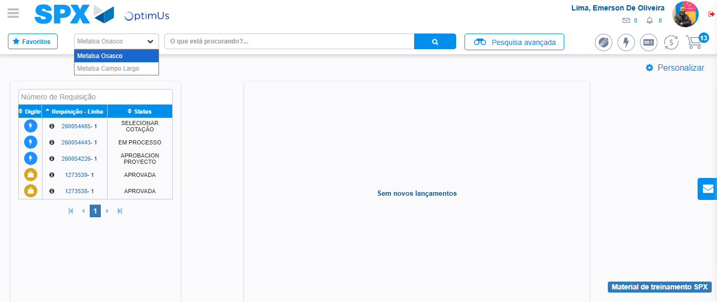Image file-name: QC_Testing-tc002_SPX_Dev5_Crear_Requisicion_Spot_Tipo_Cobro_Project-1784226431563

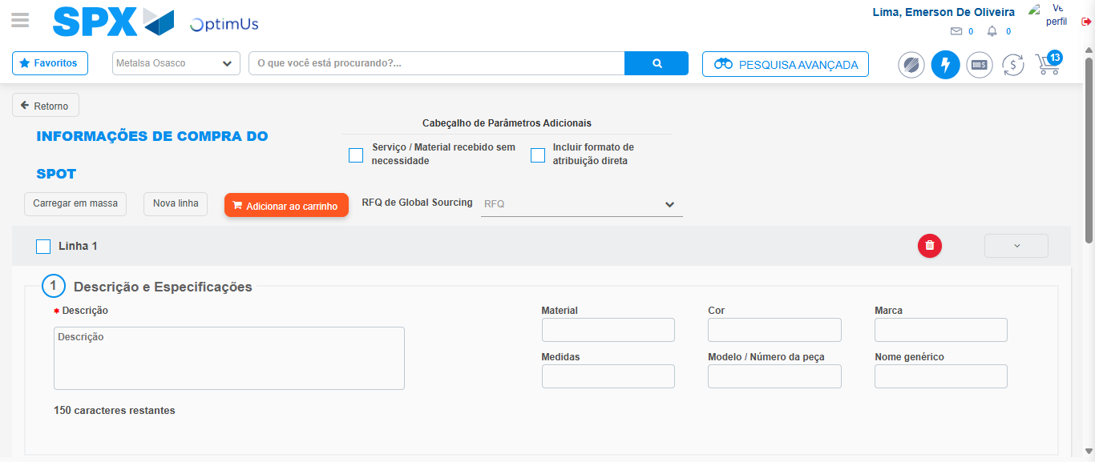Image file-name: QC_Testing-tc002_SPX_Dev5_Crear_Requisicion_Spot_Tipo_Cobro_Project-1784226451874

Step 3 - Data Capture Spot Buy Requisition: Data captured correctly
Image file-name: QC_Testing-tc002_SPX_Dev5_Crear_Requisicion_Spot_Tipo_Cobro_Project-1784226452069

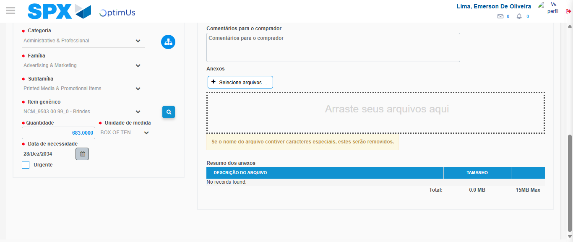Image file-name: QC_Testing-tc002_SPX_Dev5_Crear_Requisicion_Spot_Tipo_Cobro_Project-1784226463765

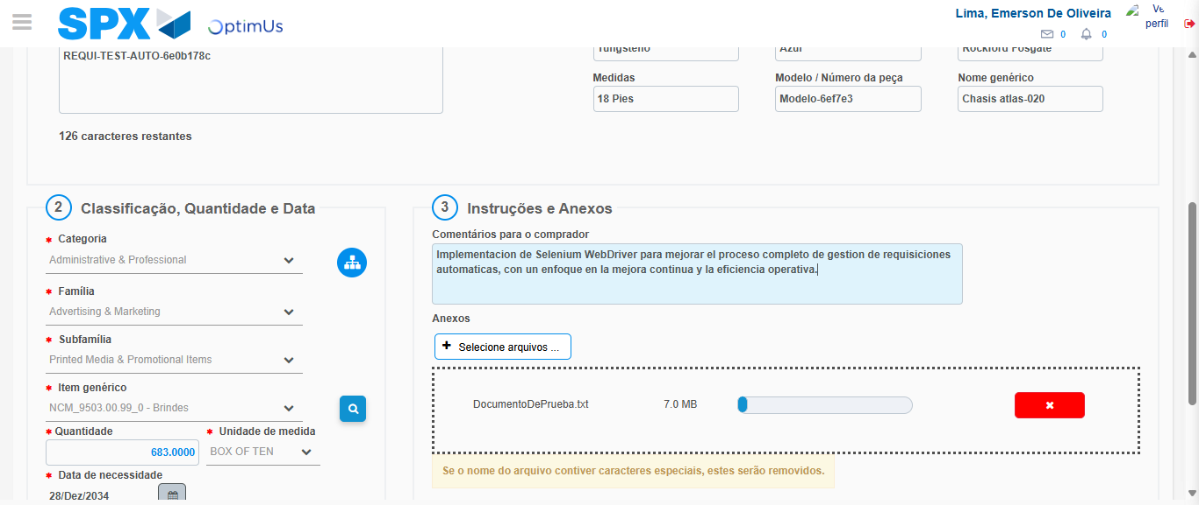Image file-name: QC_Testing-tc002_SPX_Dev5_Crear_Requisicion_Spot_Tipo_Cobro_Project-1784226464526

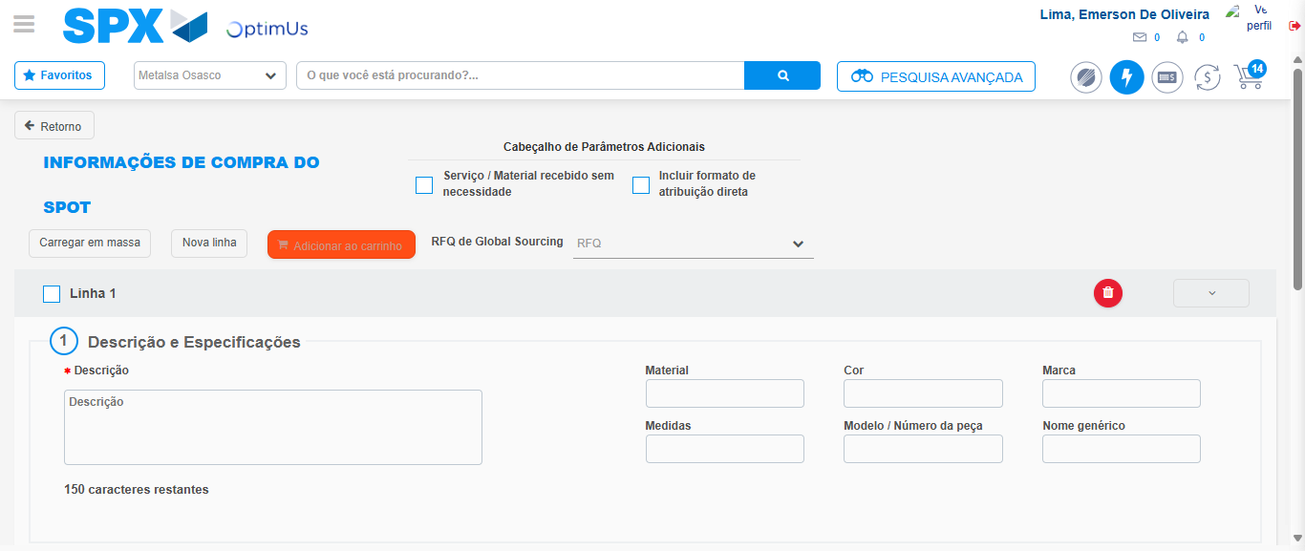Image file-name: QC_Testing-tc002_SPX_Dev5_Crear_Requisicion_Spot_Tipo_Cobro_Project-1784226466966

Step 7 - Return to Main Page SPX : Return to Main Page SPX
Image file-name: QC_Testing-tc002_SPX_Dev5_Crear_Requisicion_Spot_Tipo_Cobro_Project-1784226429132

Image file-name: QC_Testing-tc002_SPX_Dev5_Crear_Requisicion_Spot_Tipo_Cobro_Project-1784226431563

Image file-name: QC_Testing-tc002_SPX_Dev5_Crear_Requisicion_Spot_Tipo_Cobro_Project-1784226451874

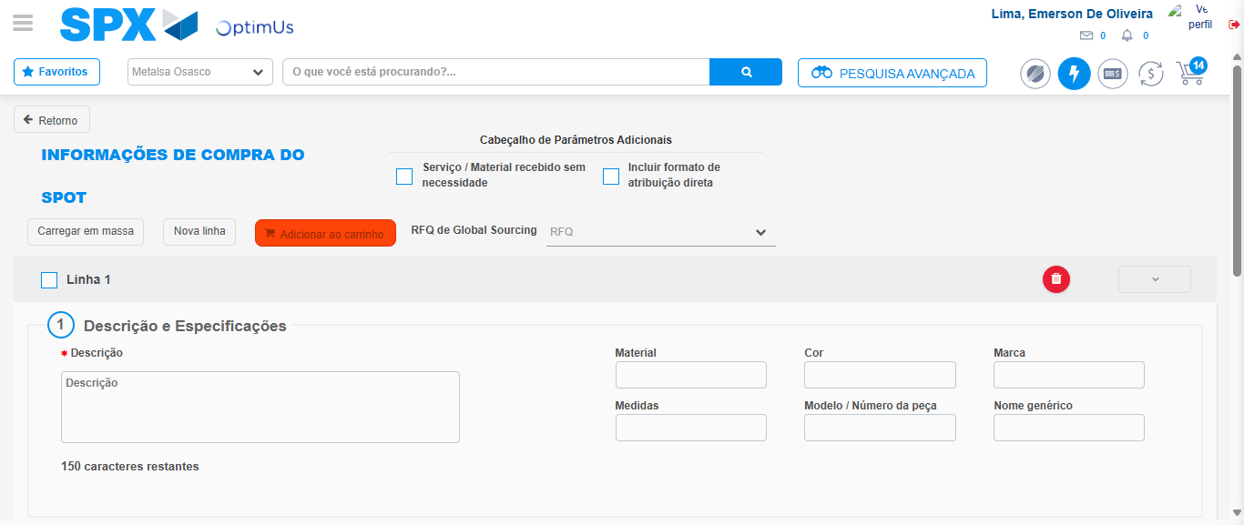Image file-name: QC_Testing-tc002_SPX_Dev5_Crear_Requisicion_Spot_Tipo_Cobro_Project-1784226469194

Image file-name: QC_Testing-tc002_SPX_Dev5_Crear_Requisicion_Spot_Tipo_Cobro_Project-1784226469361

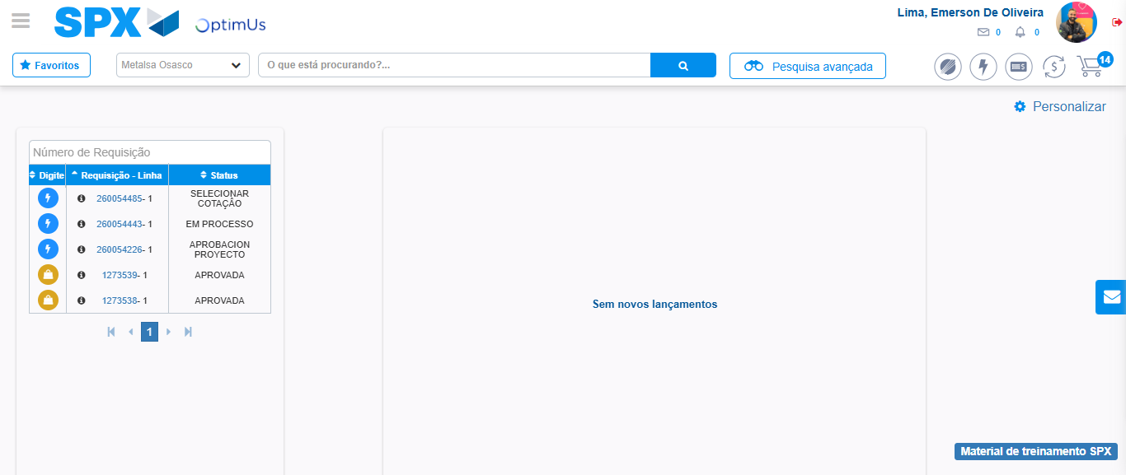Image file-name: QC_Testing-tc002_SPX_Dev5_Crear_Requisicion_Spot_Tipo_Cobro_Project-1784226490378

Step 8 - Log Out : Log Out SPX
Image file-name: QC_Testing-tc002_SPX_Dev5_Crear_Requisicion_Spot_Tipo_Cobro_Project-1784226490581

